**Insulin Sensitivity Factor ISF**

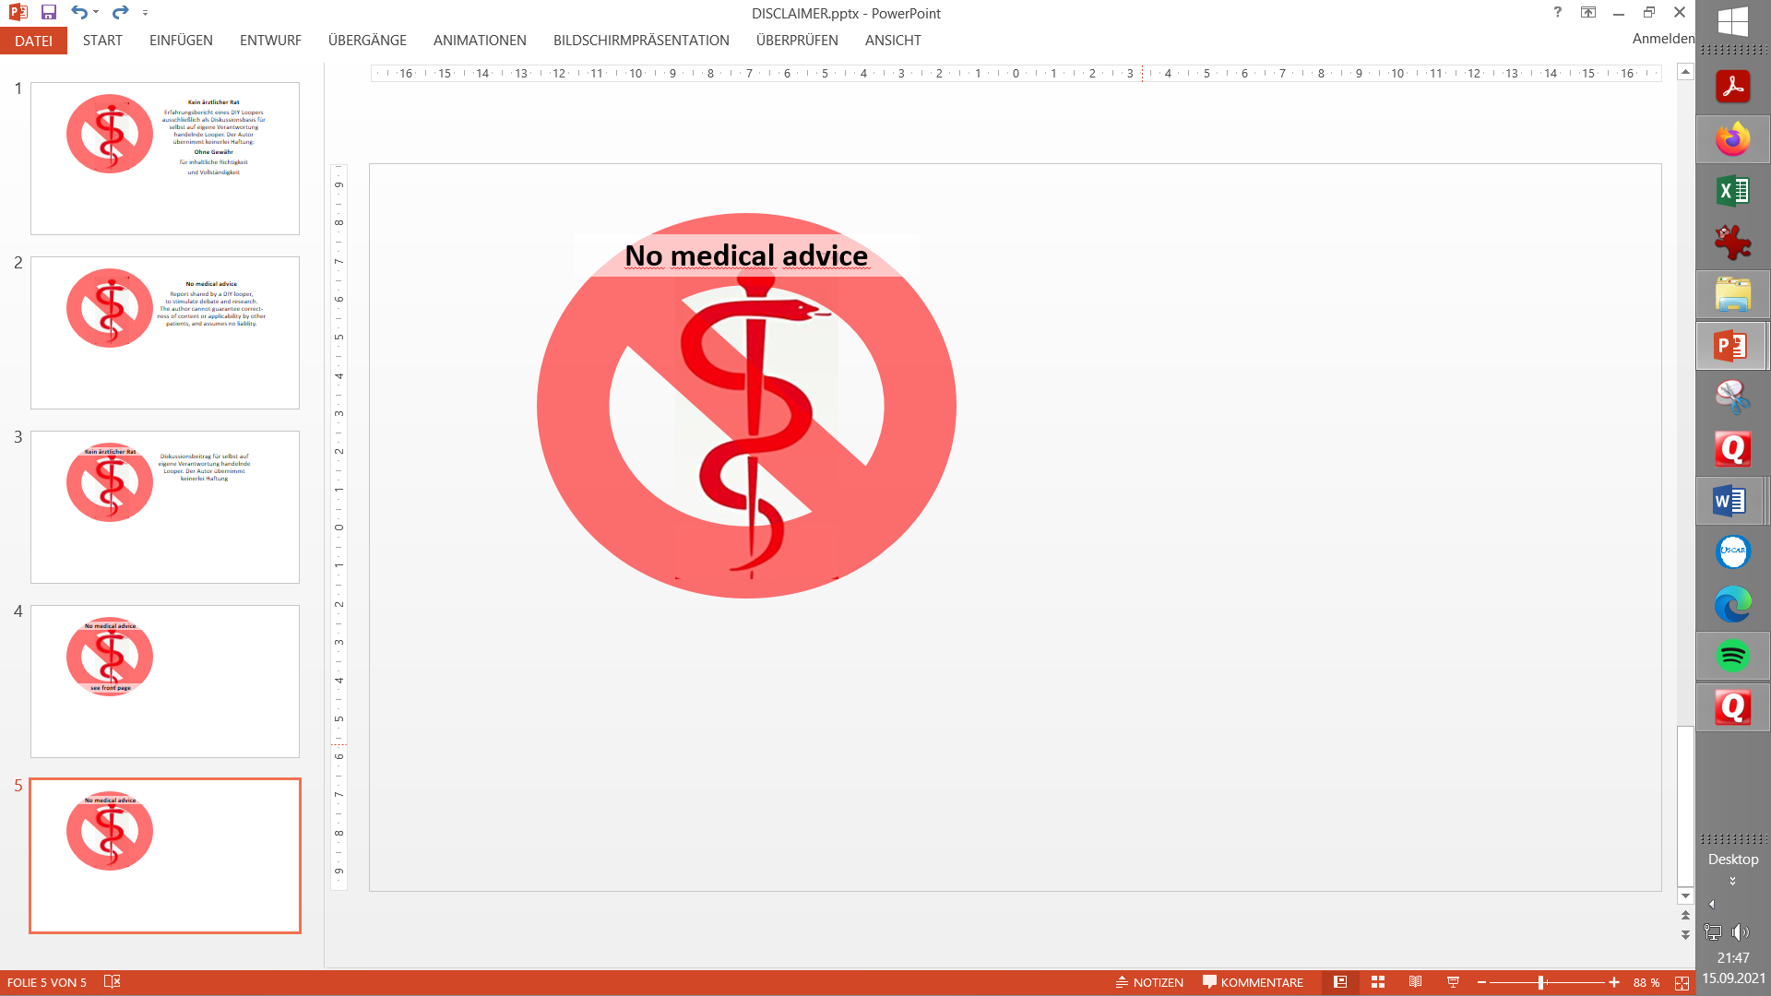

Contribution to the discussion among DIY loopers

The author assumes no liability B/ V.3.3.4next

1. What is ISF
2. Rough estimates for your ISF
3. Refined estimates via dynamic ISF
4. Determination of ISF
5. Circadian ISF
6. Signs for a wrong ISF when looping
7. Tuning ISF in closed loop
8. Avoiding hypos
9. Short-time boosts via Automation
10. auto-ISF
11. Differential diagnosis occlusion
12. Remarks regarding (ISF and) Full Closed Looping
13. **What is a ISF?**

Your **insulin sensitivity factor** (unit: (mg/dl)/U or (mmol/l)/U) says how sensitive you react to insulin, so how much your glucose level will come down per unit of insulin .

*For instance, ISF = 30 (mg/dl)/U means, per unit of insulin our glucose level goes down 30 mg/dl. For mmol, divide by 18: ISF = 30/18 = 1.7 (mmol/l)/U*

In Hybrid Closed Loop, the other profile factor, the carb ratio IC, plays the main role around meal times. However, two to three hours after any meal, the administered meal bolus rapidly loses power, but now proteins, fat, and carbs exceeding what could be digested in the first 2 hours come to absorption and require more insulin. This is where your ISF plays the (or a) major role (in iOSLoop, the IC factor continues to play a very strong role).

Remark regarding the workings of oref(1) systems, and the (limited) role carb inputs and the IC value, applied to carb info and/or to observed carb deviation, play in the loop’s management of your bg development:

The loop will not take your “e-Carb” inputs for granted and “bolus for it”. Your given carb data are used only for one of 4 predictions. The loop also (or *only, if you do no carb inputs*) uses a *prediction of further carb absorption*, which builds on the observed **carb deviation** (=hypothesis, how much got absorbed in the past 5 minute segments). Based on that calculation (which uses ISF), the loop assumes *more* carb decay *in the 5-minute segments that follow*, phasing out the carb decay in the course of the next 1 to max 3 hours. Every 5 minutes this prediction is “met with reality”, and the loop further adjusts. This is essentially why oref(1) system allow to go entirely without carb inputs. For more detail on the algo see <https://openaps.readthedocs.io/en/latest/docs/While%20You%20Wait%20For%20Gear/Understand-determine-basal.html#understanding-the-basic-logic-written-version> (or study your SMB tab info). For more info on Full Closed Loop without carb inputs see fcl-e-book in: <https://github.com/bernie4375/FCL-potential-autoISF-research->

Unfortunately, the ISF is not one fixed number you or your loop can count on (count with):

* can vary between times of day => use **circadian pattern**

=> determine it for several times during the day and night, and check whether you see a typical „circadian“ sensitivity pattern corresponding to your bio-rhythm..(As a high basal rate and a low ISF factor are signs of lower insulin sensitivity (=of elevated insulin need), the pattern must be like a mirror-image. More see in section Circadian Pattern, below)

See also: AndroidAPS Users / Files / ..circadian … Duesterhoff.xls: <https://www.facebook.com/groups/AndroidAPSUsers/permalink/2869638923257506/>

* will vary between days e.g. when hormones play into it => **Autosens**

**\*** can also fluctuate within shorter episodes, e.g. @ stress, or @ high glucose values because of **insulin resistance** after a fatty meal

**\*** varies also with **TDD** (although, to me at least, it is unclear whether this is an independent effect, or just owed to the fact that on days with high TDD typically more fatty meals are consumed, accompanied by increased insulin resistance) (Plus, we often see “fake insulin resistance” from occlusions, see section 11.)

=> Short time boosts may be required, see section 3, further down

=> Based on statistical findings, Chris Wilson recently proposed a **dynamic ISF** formula that roughly considers most of these effects (see section 3)

1. **Rough estimates for your ISF**
2. **… using Autotune** (not recommended by the author)

Autotune gives you ONE „average“ ISF. Reliability of this result is seen controversially in the looper community, largely, because Autotune relies on your data inputs which probably contain errors (like your carb inputs). Also there is no use to Autotune when you are using dynamic ISF adaptations (dynamicISF, autoISF).See also: <https://androidaps.readthedocs.io/en/latest/Usage/autotune.html>

1. **… via daily total insulin dose, TDD**

The daily total insulin need describes, roughly, the insulin sensitivity of a type1 diabetic. The following table reflects values seen in a big study.

*Example: At 35 – 40 units of daily insulin (mid of left column) an ISF of around 45 mg/dl/U (35-60) would be suspected, or around 2.6 mmol/l/U*

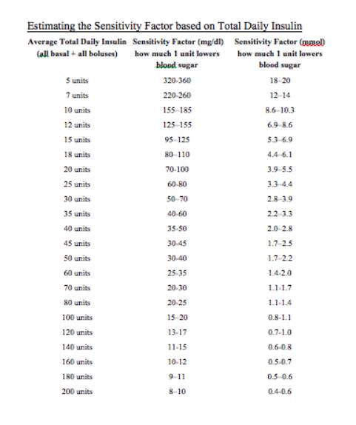

1. Estimate using the **„1700“ rule**

According to a study[*https://www.ncbi.nlm.nih.gov/pmc/articles/PMC4454102/*](https://www.ncbi.nlm.nih.gov/pmc/articles/PMC4454102/)the ISF can be estimated using:

*ISF*=1700 / *TDD (or = 94.4 / TDD for mmol)*

where TDD is the total daily insulin, determined for each virtual patient, and assuming an average diet of 180 g of carbs for adolescents and adults, and 135 g for children.

*Example as above, 35…40 U TDD: ISF = 49 … 42 mg/dl/U (or divided by 18 for mmol)*

1. **Refined estimate for your ISFs** (the 277,700 rule entering **dynamic ISF**)

According to <https://www.facebook.com/groups/TheLoopedGroup/posts/2996545667228746/> and[https://youtu.be/oL49FhOts3c](https://youtu.be/oL49FhOts3c?fbclid=IwAR0xFdQE5tHxVB-GNzoXDN9lD3iPnrgkjpwxeveIebLAKR9wf_zp1qig73c) (Chris Wilson/ see also in Loop&LearnFB)the ISFs can be dynamically modelled using the formula:

*ISF*= 277 700 / (TDD * bg) *(or = 15 428 /* (TDD * bg) *for mmol)*

Discussion: I see the results from the formula for myself too high, so that would make more cautious corrections, than what I really use. But people who have put less effort into optimizing their ISFs, who have bg values over 200 often, and maybe also a diet requiring higher TDD than I, might benefit.

As the formula is statistically derived from real-life data (sort of „top-down“), it should be useful for refining how any ISF you are working with (notably if you work with only 1 number) should be tweaked to reflect your true needs for correction-insulin better.

Plug-ins in branches are available for both, AndroidAPS (by Tim Street), and also of iAPS. To overcome major problems with the rough first approach (above ISF formula, to put it bluntly, was based on “wild” data from how “real average diabetics jerk around with their super high glucose values”), the formula has been significantly refined, and also was made user-tuneable.

We can assume that dynamicISF provides an easier-to-implement **alternative to** *what below in this paper is suggested as kind of* **a bottom-up personalized approach to good ISF settings via:**

* circadian pattern of ISFs
* boosting ISFs at high glucose values, notably if owed to post-meal insulin resistance
* use of Autosens
* use of autoISF.

If done right, the bottom-up approach based on your personal data should be better, and also more real-time reactive to changing insulin requirements, notably in full closed looping

Please apply caution if you *combine* some of the discussed methods, as they probably work in the same direction, and *could „over-adjust“* your ISFs.

1. **Determination of Carb Rise Ratio CRR and Insulin-Sensitivity Factor ISF**

**Basal rate first**

Verify that you have a correct basal rate before determining factors!

Else your ISF will have to balance errors in your hourly basal pattern, and you may lose some of the principal power of your loop.

Helpful links regarding basal rate

* A basal rate helper, drawing data from your Nightscout site (by Peter van Rijt): <https://www.nightscoutsuggestions.com/index.php>
* a good article in support of that process: [https://www.mysugr.com/en/blog/basal-rate-testing/](https://l.facebook.com/l.php?u=https%3A%2F%2Fwww.mysugr.com%2Fen%2Fblog%2Fbasal-rate-testing%2F%3Ffbclid%3DIwAR2Ybjp0gJrKH7vVEA2hKq-MO_W32WcUgVH-IYtwHSfXylEZaR8du_-9qVU&h=AT2ACPChAQ99bwoQMGZhi0gB4cDbymfhskx8kFbirUjyWsBX4tEx4W191lze9siww6Xefetskrkx09Uf7VlMFAgFLCBNA9DWA59sJNP28xsa7BxgKX2ayziyNKf26FIpuXY&__tn__=R%5d-R&c%5b0%5d=AT34zQqFKEs8_yD94N0j_AzkzgefK4M19l_Abr_ylqug4g6hHOV5GVqTXNBPJTvEv4U0JQ7fnYeLhsj2w1hSPgnwWHPvUAvFM7UOUybM1vEGVsxFcQGVC2MbjXfhGfGXKzx2qfgcQEcz13t0loK47ou3EbB7MkYkh2v4xUE)
* a process description by a commercial service, including a tool : [https://www.mevita.de/.../online-zugang-erstellung-einer.../](https://www.mevita.de/shop/webinare/online-zugang-erstellung-einer-cirkadianen-basalrate/?fbclid=IwAR310eFurEPaiIE6DSed0Ipo1s04dX5l7Jd_rsCi8X3wOoOYP4vOmwLEEX4)

Although I advise to determine your true, likely **circadian**, basal rate: It can be „good enough“, and advantageous especially for small kids, to simplify things and assume a (in case of doubt, low) **flat basal rate**, together with a well-contoured ISF pattern („with enough bite where it counts“). Discussions on this topic can be found in looper sites using the search term “flat basal rate”. Interpret enthusiastic reports on flat basal with caution, though. Positive observed effects are likely coming from significantly increased attention to ISF … and this brings us back to our topic☺ …

**Start your ISF test with a CRR determination**

To determine ISF, select a day without prior strenuous exercise/activity, without exceptional stress, or infection.

As testing for ISF must start out with a high plateau of glucose level, it makes a lot of sense to do a determination of your **CarbRiseRatio CRR** first:

(In a relatively stable, normo-glycemic phase) take a sweet drink with a known carb content, and watch (in Open Loop, not giving any insulin except profile basal rate) by how many (mg/dl) glucose rises, until reaching a plateau (in about 1 hour).

*Example: After consuming 20g, my glucose rises from 90 to 190 mg/dl.*

*CRR = (190-90)mg/dl / 20g = 5 mg/dl / g*

**ISF determination**

Now, having reached a high plateau *– at 190 mg/dl in our example ,-*we move on to determine the **ISF***.*

Inject (still in Open Loop, with profile basal running), an amount of insulin as you typically would (considering your personal insulin sensitivity). *Example: 2 units*

**Caution:** For a kid you would use much less than 2 U: Think about typical correction boli in the past, or use your “suspected” ISF (if it is over 100 mg/dl/U then you definitely should stay under 1.0 U)..

Then watch for about three hours until a deeper plateau is reached, *for example at* *110 mg/dl.* Then you can evaluate:

*Example: 2 U of insulin lowered my glucose by 80 mg/dl . Hence, ISF = 40 mg/dl / U*

*Off topic remark:* Using CRR and ISF you can also calculate your IC for this time of day, or *check the* ***plausibility of the IC*** you are already using, because:

**ISF** (mg/dl decrease per unit of insulin) **/ CRR** (mg/dl increase per g of carb) **= IC** (g carb per unit of insulin) (similar in mmol) or also: CRR = ISF / IC

*IC in the example from above: ISF / CRR = 40 (mg/dl)/U / 5 (mg/dl)/g = 8 g/U = IC*

See also:: <http://seemycgm.com/2017/10/29/fine-tuning-settings/>

The CRR is relatively stable (does not vary by much over 24 hours): - while both ISF and IC do vary (in similar ways, related to your insulin sensitivity) - if you divide one by the other, deviations owed to sensitivity cancel out.

1. **Circadian pattern of ISF**

ISF varies over 24 hours according to a „circadian“ pattern of varying sensitivity to insulin.

See AndroidAPS Users / Files / ..circadian … Duesterhöft.xls: <https://www.facebook.com/groups/AndroidAPSUsers/permalink/2869638923257506/>

*Example*

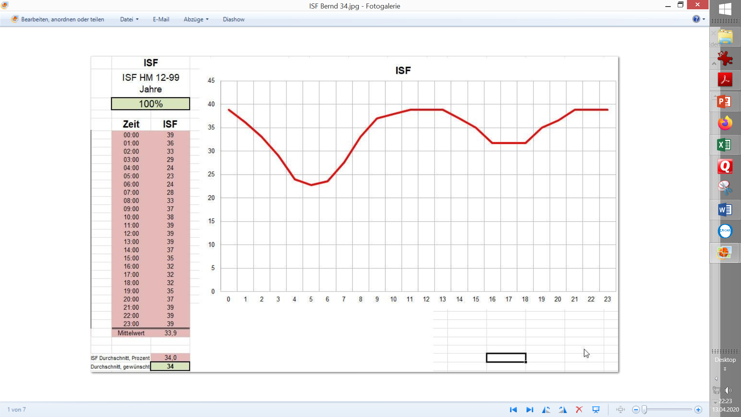

Do not just copy a pattern that may be valid on average for T1Ds out there, or for a single other person! For instance, I am more of a night owl, so that curve shifts 1-2 hours to the right.Likewise, if you do shift work or cross-time-zone travel, keep an eye on your (probably time-delayed) adjustments of your body‘s insulin sensitivity.

The deepest dip in ISF, and highest hill in hourly basal, is typically an hour or twao before getting up and breakfast. However, I usually skip breakfast, so I „break my fasting“ (!) for lunch and see higher insulin sensitivity there than the standard curve suggests. (Another explanation could be, that others would have tail of insulin sensitivity from breakfast still at work supporting insulin for lunch (with a typical breakfast, low in fat and protein).

*In case you work with a flat basal rate*, your ISF should look even more „contoured“: For instance, if you use your low hourly basal, as approriate in most night hours, for all 24 hours, the daytime ISFs would need to be make up for „deficiencies“ in your hourly basal; likely morning and evening ISFs would dip relatively lower even than in picture on preceding page. YDMV!

So, determine **your** ISF for a couple of times, in which you find high values which your loop needs to regulate down (one of them, inconveniently, probably being after midnight; see also 2 sections lower).

You can interpolate for the hours for which you did *not* „experimentally determine“ your ISF. Follow the idea (or data) you have regarding your general pattern of insulin sensitivity.

**Caution regarding kids**

For kids, the 24 hour sensitivity patterns can differ strongly from adults and can also change strongly in certain growth phases, see the following graph (shared by „basal rate guru“ Heiko Mueller, [www.mevita.com](http://www.mevita.com))

To help “construct” a circadian profile for kids, there is a “profile helper” in AAPS:<https://androidaps.readthedocs.io/en/latest/Configuration/profilehelper.html#profile-for-kids-up-to-18-years>

The following graph shows typical circadian patterns for basal rates, and is normalized to 100% being the total daily basal.

So, the graph below says how much %of the daily total is needed in every hour of the day. It does NOT show the very significant differences in basal insulin need between the age groups! We are looking only on the 24 hr patterns here!

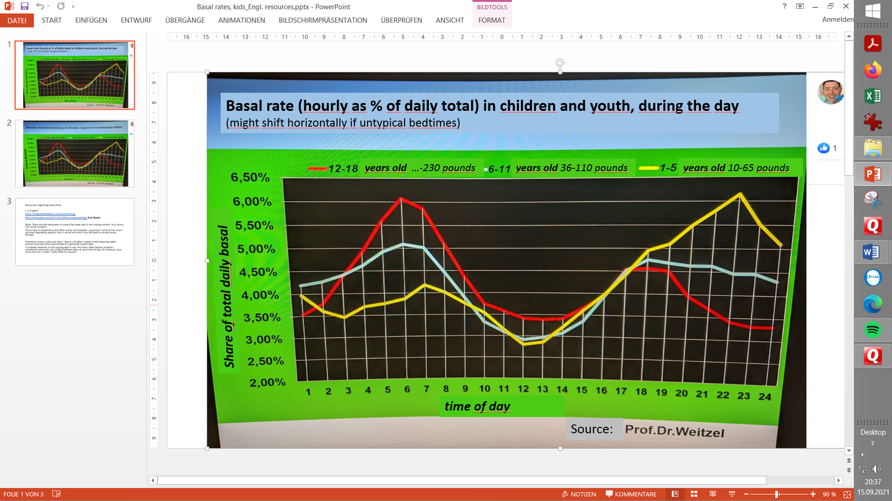

The graph is for basal pattern.

For ISF the curve would look „opposite“ (~mirrored on x-axis), because **higher** basal („mountain“) = lower insulin sensitivity = higher insulin need = **lower** ISF factor („valley“). *For the red curve (age 12-18 resembles adults fairly well already) we see this mirrored pattern beautifully in the ISF graph, 2 pictures higher up.*

1. **Signs for a wrong ISF when looping**

If your ISF is too strong (in other words the actual number is too low compared to reality of your real insulin sensitivity), one of the most common symptoms you’ll see in closed-looping is a roller coaster of glucose values, and the temporary basals might be cycling between zero and high temping.

If ISF is too weak, the glucose is not corrected down to target (or this happens only extremely slow).

If you observe such behaviour in certain time periods of your day, you might consider changing the ISF by plus 10-20% (if ISF seemed too strong) or by minus 10-20% (if ISF seemed too weak), and see (with alarms set on loud), whether the situation improves next day.

1. **Tuning your profile ISFs in Closed Loop**

Caution: The following applies to using and tuning *profile ISF*!

Tuning *dynamic ISF* (if you use that plug-in) requires different considerations: Look up in your data which part of the “dynamic range” of ISFs resulting from the used formula is actually in use to correct your glucoses, and how to influence that via your tuning. Refer to different resources for advice.

The effects of a suboptimal ISF settings as discussed in the preceding chapter can be seen nicely in the night following a bigger dinner. When the meal time bolus loses power, about 2-3 hours after starting the meal, often relatively high glucose values exist at bedtime for the loop to take care of.

With a good ISF setting, the glucose curve will, within a few hours (while you are sleeping), go down and „hug“ the glucose target you have set for the night time.

If the glucose curve swings very much below target, or even triggers a hypo alarm, ISF is probably too strong, and you should elevate the nightime values in your profile and observe again in the following nights.

Conversely, if the glucose hovers for hours above target: In that case you would try with lower ISF next nights. Make changes in small steps (hypo danger) . Don’t do this after a day with strong activity/exercise. Setting the nighttime glucose target a bit higher for the time of testing can also be a good idea.

1. **Avoiding hypos after correcting high glucose values**

The course of insulin activity during the 5 hour+ „DIA“ period of any administered bolus implies that anything you try to achieve for short-term glucose control (1-2 hour time frame), comes with a „burden“ of effects that tend to drive your glucose below target a bit later

A high glucose value therefore can not be corrected rapidly without running a risk to go into a hypoglycemia 2 or more hours later (as probably everybody has experienced with impatient „rage“ bolusses).

All loops apply caution in that they analyze the situation every 5 minutes, and generally apply much less than the calculated InsulinRequired (AndroidAPS generally applies 50% of what the calculation suggests). (To avoid misunderstanding: This does not mean that 50% of insulin is really withheld ; what was not given in the preceding 5 minute segment, is likely missing „on top“ also in the following 5 minutes, and gets delivered to, again, 50% then , now making up already 75% of the previous InsulinRequ. …).

Users of iAPS and of AAPS dev variants that allow SMB delivery ratios bigger than 0.5 should be aware that changing to 0.6 means already a 20%, and to 0.75 a 50% boost for the insiulinRequired calculation. Going far over 0.5 can become dangerous, e.g. if a single jittery CGM value can be trigger much bigger SMB than really needed.

It is important to watch your loop with some patience, and to analyze what (if anything) you might try differently *for the next day(s)*.

In case your loop is acting too aggressively, you may need to take a couple of grams of carbs to avoid going low. (If you use AndroidAPS, your main screen probably shows carbs required in next minutes, to boost the cob number which is given right next to it), Note down how many grams you took *for example,. 4 grams .* Using your IC factor, *e.g.. 8 g/U*, calculate how much insulin (*0,5 U*) would be needed for absorbing these extra grams. Your post-prandial SMBs should have given that amount of insulin **less** (assuming you observe that things go well with these extra 4 grams) For example, if your pp. SMBs were *4 U* in total, *you should try 3.5 U next time..Your ISF factors in the relevant hours should be elevated by 14% (=4 / 3.5).*

To summarize:

1. Try to avoid high glucose values (see material on meal management in hybrid closed loop)
2. If high values occur: First exclude occlusion as underlying problem. (see section 11).
3. Watch and analyze your loop preferably without giving extra boli (but take, and record, anti-hypo snacks if needed), Define what you might change to improve in the next days.
4. In case you think you see very short-lasted resistance, e.g. from fatty meals, consider brief boost of ISF (next section).
5. **Short-time „boost“ of ISF** (in AndroidAPS also via **Automation**)

Background: Often a short phase of insulin resistance is encountered a few hours after a fatty meal. Insulin seems to have lost it‘s potency for 1 or 2 hours. This is often assigned to receptors blocked by free fatty acids, and requires extra insulin – but only for a very limited time, until the receptors are cleared -.

Rather than taking care of this phenomenon by giving an extra manual bolus, AndroidAPS allows an elegant automated solution for this problem: When conditions like glucose above 180 mg/dl (and others, like iob thresholds, time of day where the problem is likely etc) are fulfilled, a more aggressive ISF can be selected *(for example, by setting 130% profile (‚override‘) for 8 minutes.*

Such automations are technically very easy to „program“, but require attention to one’s own daily patterns, to define a truely personalized problem solution.

Details see for example at <https://androidaps.readthedocs.io/de/latest/Usage/FullClosedLoop.html#stagnation-at-high-bg-values>

1. **Auto-ISF**

Auto-ISF is a feature (currently, Jan. 2024, not yet included in AndroidAPS Master), which allows flexible boosting of ISF. (So it will *not* help you find “your ISF values”!).

AutoISF **uses your profile ISFs**, to adjust them further for optimal management of how your glucose curve is predicted to further develop.

The working principle of Auto-ISF is, to provide sharpened ISF factors (and there are various new parameters in /Settings to tune this individually), depending on;

1) Glucose plateau = how high glucose is, and for how long it is that high already. – (This provides a “more elegant” solution of the problem we just discussed in section 9).

2) Glucose level = allows to sharpen ISF at high glucose levels (I am not using this, because it is kind of late to react then; also, if my glucose runs really high, this is usually occlusion related = ISF does not help at all then, see section 11. But in Hybrid Closed Loop, if you often find yourself high when your given bolus expires, the feature might help/YDMV)

3) Glucose delta = sharpen ISF when glucose rises strongly. It makes a lot of sense to act BEFORE glucose is high, and you can tune aggressiveness according to personal needs.

4) Acceleration of glucose rise = enables strongest ISF as soon as a meal-related rise is detected (and, in balance, allows reducing the aggressiveness – already during the glucose rise! - when curve bends around heading towards a peak). This is extremely helpful in UAM Full Closed Looping, but requires a smoothly operating CGM, so what the sophisticated math makes of your glucose curve, to fire off boosted SMBs, is not just a temporary artefact.

Any of these 4 autoISF varieties can (must) be tuned separately, but also can interfere with eachother and with Autosens. For more details see fcl-e-book in: <https://github.com/bernie4375/FCL-potential-autoISF-research->

**11. „Differential-diagnosis“** **occlusion when dealing with high glucose values**

Back to easier stuff, relevant to us all.

When we encounter high glucose values it is very **important**, as a first step, **to exclude a compromised insulin delivery** as underlying cause.

Users of Lyumjev or of Fiasp seem to experience occlusions quite often, especially if not changing cannula frequently. Under the skin, near the insulin insertion site, partial or full blockages can occur and insulin is being pushed back out into the adhesive patch of the cannula. This results in glucose rising despite **(fake) high iob**.

In such instances, loop should be switched off. The share of insulin that did not effectively enter the body system must be estimated (conservatively, in case of doubt), and erased (in AAPS: Treatments tab/Bolus/erase a number of entries there), so a realistic iob number is there for the loop to continue .The occlusion must be resolved (usually by setting a new cannula) , and the high glucose must be treated. As your iob estimate is likely uncertain, do this conservatively, and continue in closed loop with alarms set on loud .

In case the high values were realized only after a couple of hours, watch out for signs of **Keto-Acidosis** and be ready to follow a treatment scheme for it. Hospitalization may be required.

**Off Topic:** Also **fake cob** can happen. This would develop **after throwing up** shortly after a meal which you bolussed for. As insulin cannot be removed from the body, and glucose snacks etc.- which are needed in significant quantity quickly now - , likely are also thrown up, a glucagon injection may be needed.

Caution: To stop more insulin delivery, and erase false cob, is by far not sufficient to resolve this crisis. This is an **emergency** with extremely high hypo danger at the rapidly approaching point of time, when your meal bolus reaches maximum activity! Call for emergency: * if you can’t eat/drink (or not keep it in) * if you go below a certain glucose value that you laid out for yourself when still clear in the head. (It probably would be too complicated to build a strategy on the 5-minute delta glucose values, and amount of carbs you were successfully taking)

Especially users of Lyumjev or Fiasp should be aware how fast glucose can sink in absence of sufficient carbs for the iob that is present.!

**12. Remarks regarding „UAM“ Full Closed Loop**

With well-functioning CGM and a rapid insulin (preferably Lyumjev), more and more – currently mostly adult – loopers establish a reasonably functioning Full Closed Loop with AndroidAPS (also without having a low carb diet). More info see here: <https://androidaps.readthedocs.io/de/latest/Usage/FullClosedLoop.html>

In Full Closed Loop (UAM/no bolus/no carb inputs) **ISF is the key parameter** **because** no more meal boli are given, and **the loop exclusively reacts on rising glucose**.

Full Closed Looping had been pioneered by some low carb OpenAPS Loopers, but picked up momentum when in 2020 Lyumjev became available in an increasing number of markets.

There are currently several avenues established or explored towards a no-bolus no carb-inputs Full UAM Closed Loop. For more info see fcl-e-book in: <https://github.com/bernie4375/FCL-potential-autoISF-research->